SDSLabs Winter of Code
StudyPortal
( A Smart Learning & Progress Tracking Web App) Rafia Minhaj

Personal Information
Name: Rafia Minhaj
Branch: Computer Engineering
College: CIT Ranchi
Enrollment No: 23040550
Github: https://github.com/Rafiaminhaj

Contact Details
Mobile: 6206675008
Email: rafiaminhaj423@gmail.com

Coding Skills
Fluent in C++ (OOPs)

HTML & CSS

Python

Version control using Git & GitHub

Comfortable with basic CLI commands

Beginner in Flask (backend development)

Beginner in Figma (UI/UX wireframing)

Worked with APIs (Groq, Google Cloud)

Built a Flask-based website (1st place – Syntax Error Fresher’s Track

Project Info
StudyPortal is a simple and efficient web-app that helps students access notes, practice questions, and track their study progress in one place. The platform provides chapter-wise materials, quizzes, and a Student Progress Tracking system that shows strengths and weak areas. The goal is to make studying organized, fast, and stress-free through a clean interface and personalized learning flow
- Access organized study materials quickly before exams
- Practice DSA problems through topic-wise sets
- Generate and follow personalized study schedules
- Track study progress with simple insights and stats

Impact
- Reduced time spent searching for study materials
- More efficient exam preparation with structured resources
- Improved consistency through personalized study plans
- Better understanding of progress with simple visual tracking

Tech stack
- React.js for frontend UI
- Node.js & Express.js for backend APIs
- MongoDB / MySQL for database storage
- HTML, CSS, JavaScript for core web structure
- Git & GitHub for version control
- REST APIs for data handling and integrations

Goals

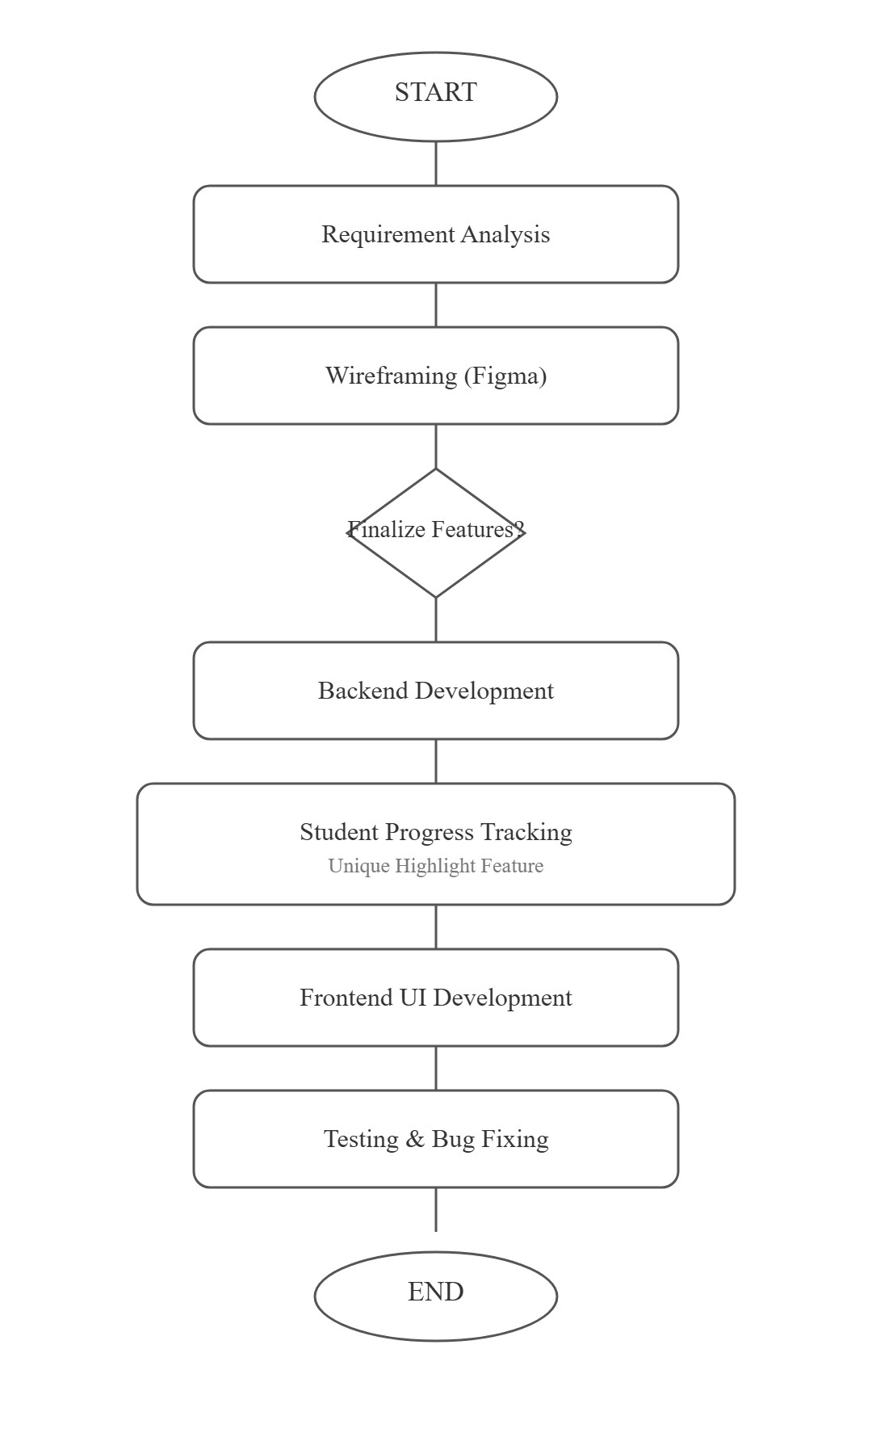

# Primary Goals
- Generate detailed day-wise study plans with subject, topic, duration, and difficulty
- Auto-suggest the next 3 best topics based on:
  - Time required
  - Difficulty level
  - Topic type (theory, numerical, revision)
- Show a complete study flow: topic → subtopics → practice → revision.
- Provide tips, key points, and important formulas for each topic.
- Store all created study plans in a personal collection for future reference.
- Take one input topic and create a complete study roadmap + add it to the collection automatically.

# Secondary Goals
- Allow students to share study plans with friends or classmates.
- Enable group collaboration on shared study plan.

Timeline
(Mentioned are supposed to change after feedback from the mentors)

Week 1: Dec 9 – Dec 14

Goal: Planning + Design + Setup
- Project requirements finalization

- Wireframing all main pages in Figma (Home, Dashboard, Courses, Progress)

- Tech stack final decision

- Folder structure + project initialization

- Student Progress Tracking – feature planning

- Research: Google API useful links + Groq AI setup

- Recap Flask/Django basics

Week 2: Dec 15 – Dec 21

Goal: Core Architecture + Basic Modules
- User Authentication (Sign In, Sign Up, Logout)

- Role-based system (Student / Teacher / Admin)

- Home Page + Dashboard UI

- Study Material Module (Upload, View, Download)

- Database models: Courses, Lessons, User Progress

- Student Progress UI – layout design

Week 3: Dec 22 – Dec 28

Goal: Main Features + Progress Tracking
- Complete Student Progress Tracking System

○ Completed chapters

○ Time tracking

○ Streak system

○ Progress graphs

- Quizzes / Assessments Module

- Groq API integration (Summaries, Explanations, Chat Support)

- Search feature for study content

- Admin dashboard base version

- Responsive UI improvements

Week 4: Dec 29 – Jan 4

Goal: Polishing + Testing + Finalization
- Optimization & performance tuning

- UI improvements + minimalistic theme polish

- Final progress analytics page

- Documentation (README + API Endpoints + Screenshots)

- Prepare final presentation slides

- Final testing & bug fixes
+---------+-------------------+-------------------------------------------------------+
| Week | Dates | Key Tasks |
+---------+-------------------+-------------------------------------------------------+
| Week 1 | Dec 9 – Dec 14 | - Planning & requirements |
| | | - Figma wireframes |
| | | - Tech stack + setup |
| | | - SPT (Progress Tracking) planning |
| | | - Google API & Groq research |
+---------+-------------------+-------------------------------------------------------+
| Week 2 | Dec 15 – Dec 21 | - User authentication |
| | | - Role-based access |
| | | - Dashboard UI |
| | | - Study Material module |
| | | - DB models (courses/progress) |
+---------+-------------------+-------------------------------------------------------+
| Week 3 | Dec 22 – Dec 28 | - Student Progress Tracking system |
| | | - Completion/time/streak tracking |
| | | - Quiz module |
| | | - Search feature |
| | | - Groq AI integration |
+---------+-------------------+-------------------------------------------------------+
| Week 4 | Dec 29 – Jan 4 | - UI polish |
| | | - Optimization + bug fixes |
| | | - Analytics page |
| | | - Documentation + PPT |
+---------+-------------------+----------------------------------------------------

Context
Since my school years, I have always been deeply interested in development and building projects that genuinely help students like me. While studying, I often struggled with finding organized notes, maintaining consistency, and properly tracking my progress, which made me realize how important a structured study system is. This inspired me to create a Study Portal that brings everything into one place — study materials, AI assistance, and a complete student progress tracking system. My goal is to build something that is simple, effective, and genuinely helpful for students facing the same problems. I am also actively exploring fields like AI, Deep Learning, LLMs, and modern development frameworks, because I want to continuously improve and build better solutions in the future. WOC gives me the perfect opportunity to learn, grow, and convert this idea into a real, impactful project that students can rely on.

About Me
My name is Rafia Minhaj, a passionate learner and aspiring developer driven by the desire to build impactful digital solutions for students. I have a strong interest in web development, AI-powered tools, and creating products that improve the learning experience. Over time, facing challenges like unorganized notes, lack of consistency, and no reliable way to track study progress made me deeply aware of the gaps in a student’s academic workflow. This motivated me to work on my current project — a smart and structured Study Portal designed to simplify learning through organized materials, AI assistance, and an integrated Student Progress Tracking system. I constantly push myself to explore new technologies, refine my skills, and build solutions that are both practical and meaningful. Through WOC, I hope to grow as a developer, gain real-world exposure, and transform this idea into a polished and impactful project that genuinely supports students.

Thank you

